USKUDAR UNIVERSITY

FACULTY / INSTITUTE OF ENGINEERING AND NATURAL SCIENCES

COMPUTER ENGINEERING DEPARTMENT / PROGRAM

2020-2021 FALL

FINAL PROJECT REPORT

STUDENT ID: 170201002

NAME LASTNAME: TOLGA BERK ORDANUÇ

PROJECT TITLE: Analyzing Famous Iris Dataset

1. INTRODUCTION

I chose maybe the most famous dataset for this project which is iris dataset. It is donated to the community in 1988 and collected/created by R.A. Fisher.

It consists of 150 samples for iris flower. It is equally divided to 3 types of iris plant (Iris Setosa ,Iris Versicolour, Iris Virginica). It has 4 features for every plant in the set.

The task is predicting which class is the plant based on those 4 features.

1. MATERIALS AND METHODS

<http://archive.ics.uci.edu/ml/datasets/Iris>

dataset has four features for each plant. Which are length and width of the sepal and petals.

First of all let’s get some basic statistics, [Graphics](../index.html)

// that’s all I got man

1. TOOL

I chose Rapid Miner as my data mining tool.

Here is the steps to configure it and get results for this dataset.

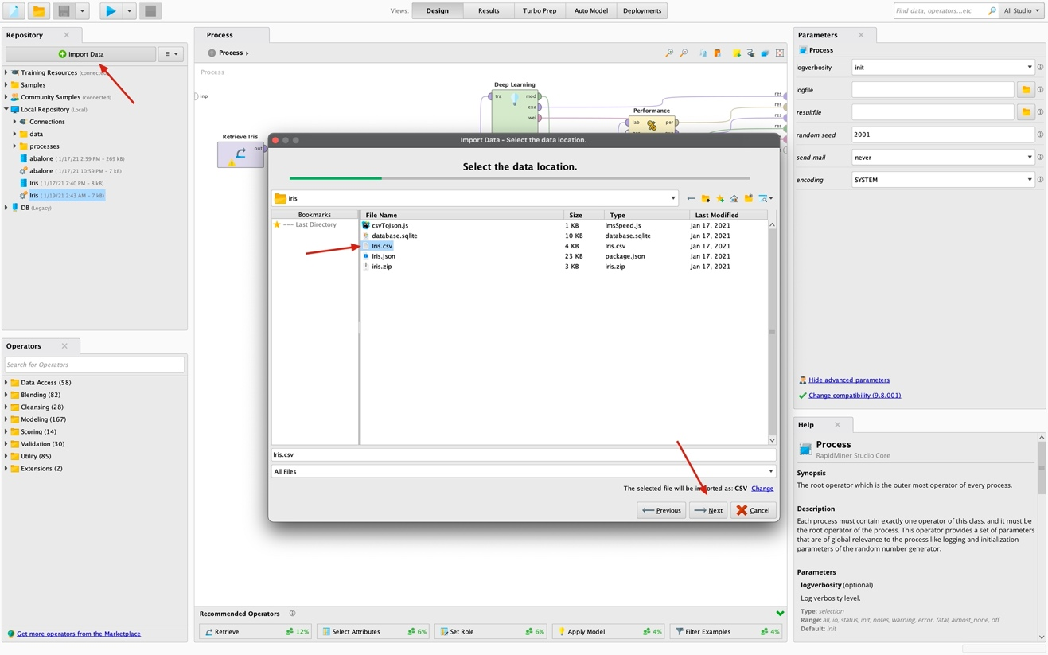First we import iris dataset to rapid miner as shown.

Here is our imported dataset. I just dragged it to process section.

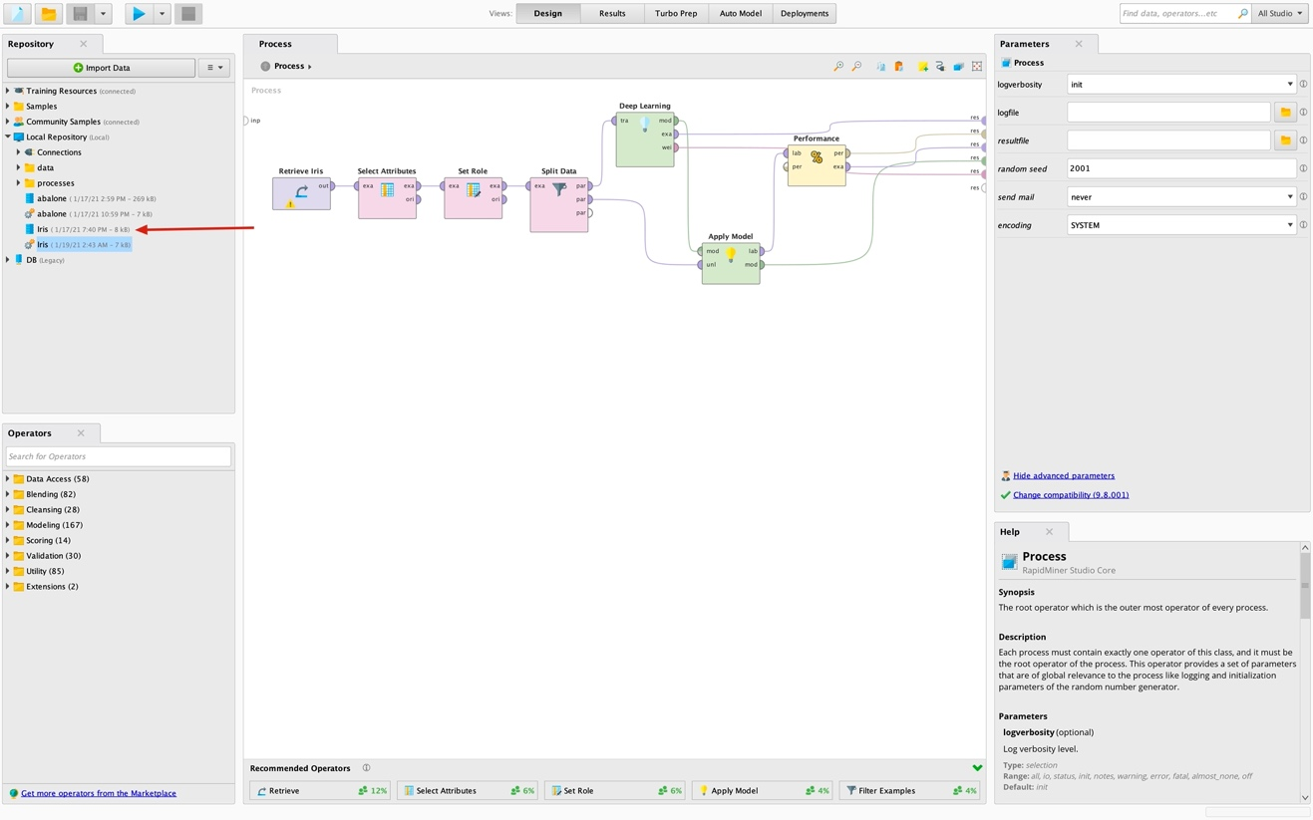

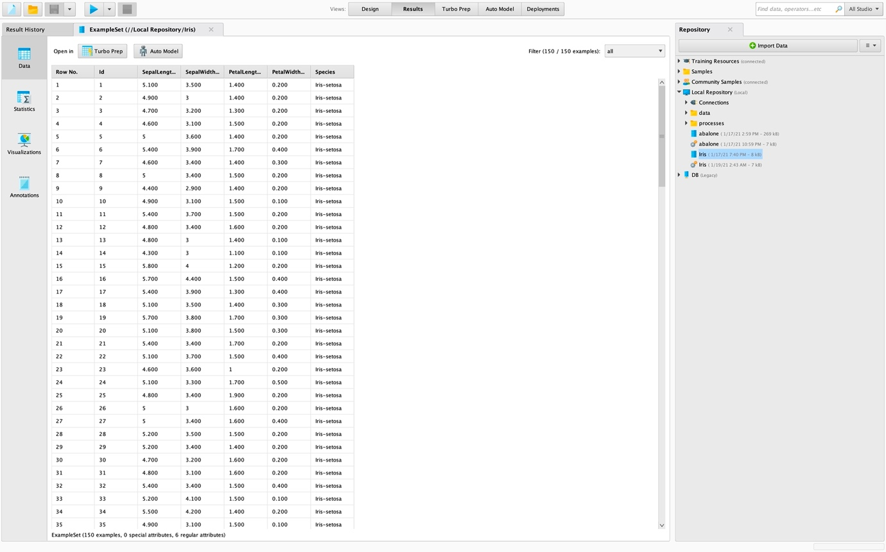After I dragged it I connected the output port of the node to one of the res ports on the most right. After I ran the process with the button on up left corner, I was able to see the dataset.

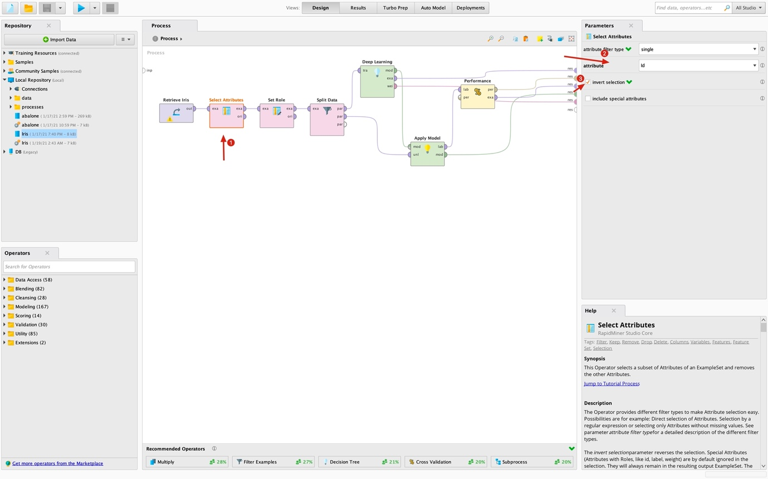After that I got rid of the id property with select attributes operator.

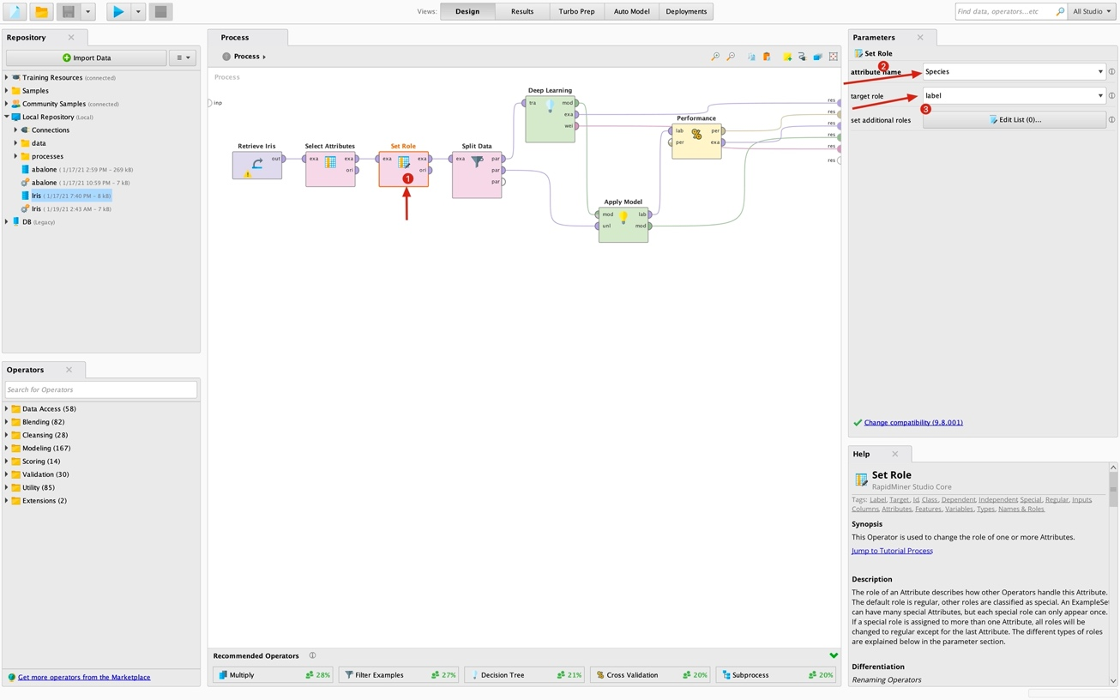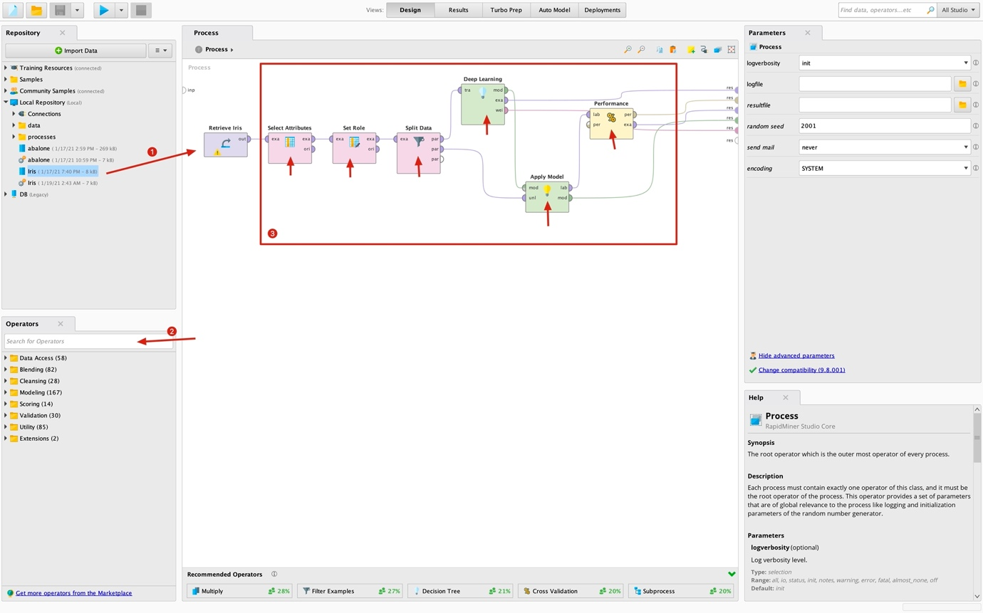In the process section there are nodes which I put in a certain order. Those nodes which are indicated in red square came from the operators section as shown with the #2 arrow. Only the first one came from the repository section because it is our dataset.

Then we need to specify a label property in our dataset in order to rapid miners deep learning node to operate.

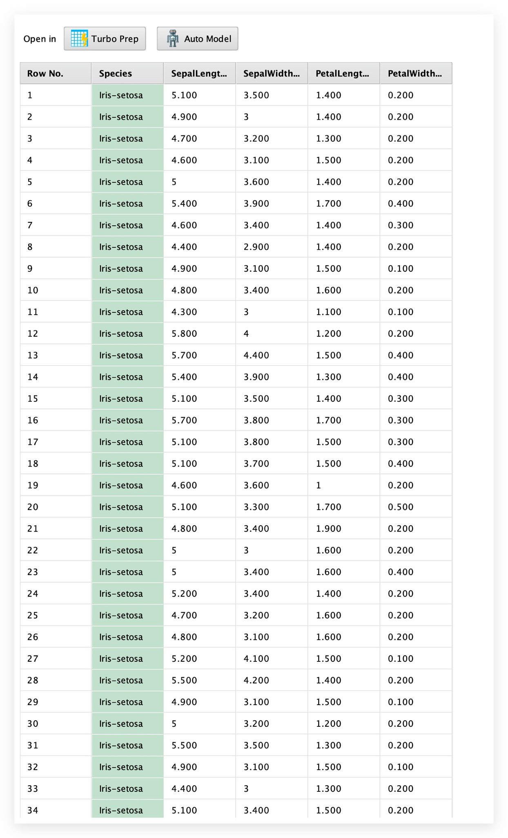After we specified it, our dataset should be appear as this.

And then we split the data by 0.7 / 0.3 ratio with the split data node to train and test the model afterwards.

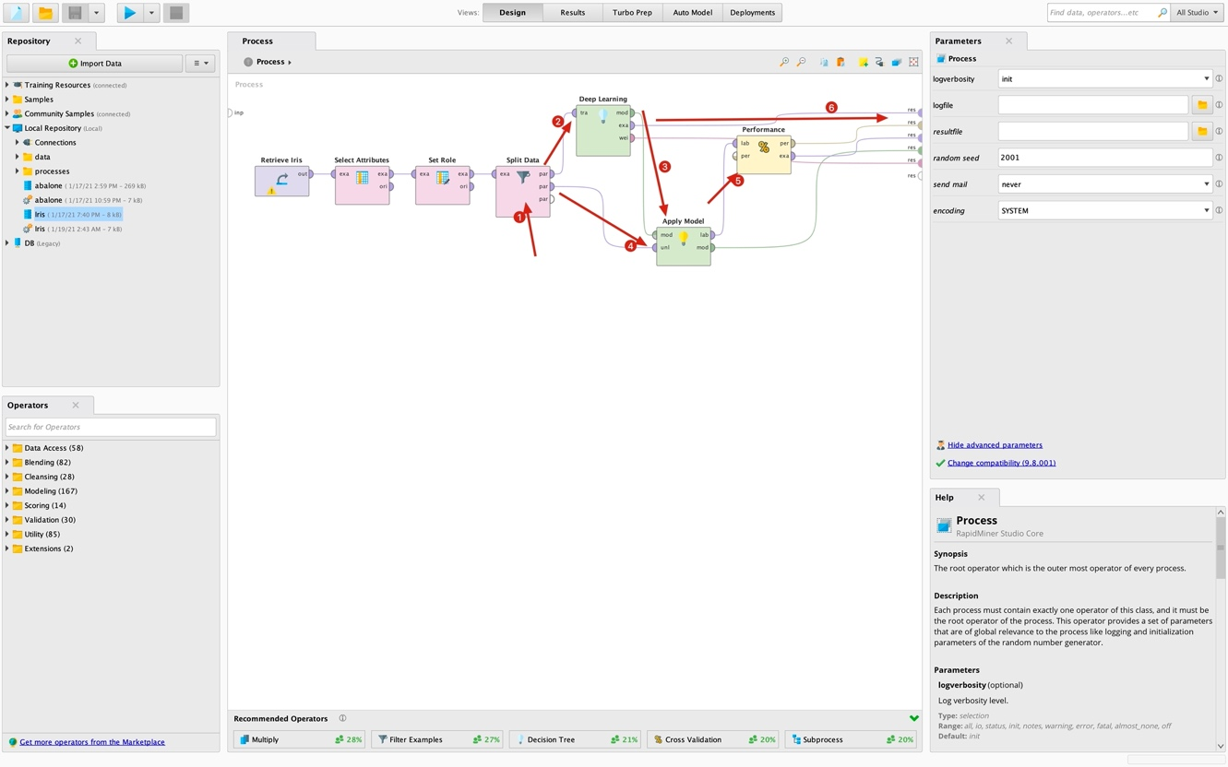After, we placed the performance node to output of the apply model node. We are ready to run our model on iris data.

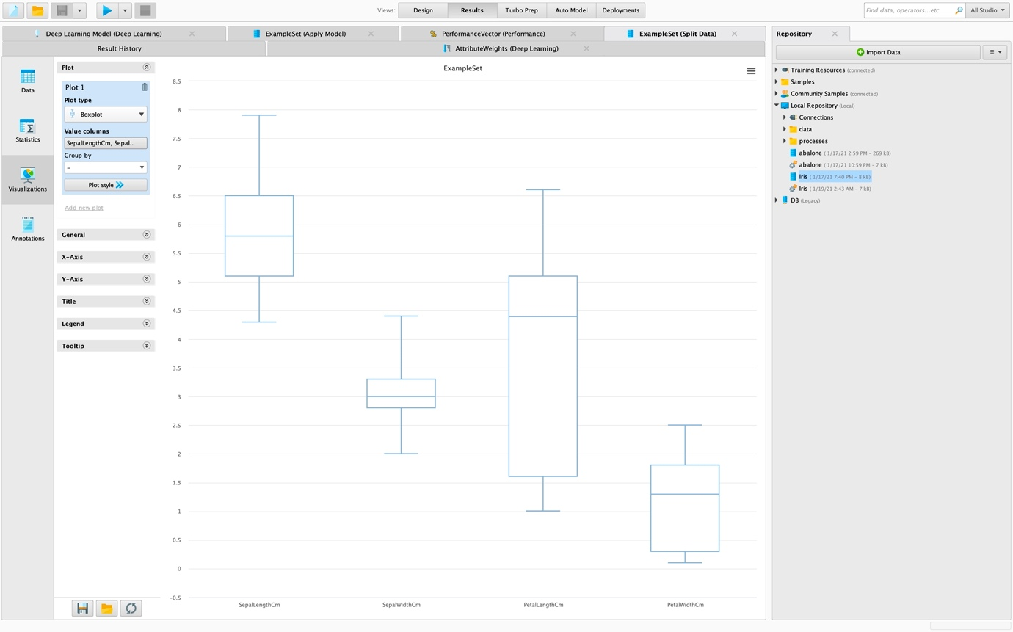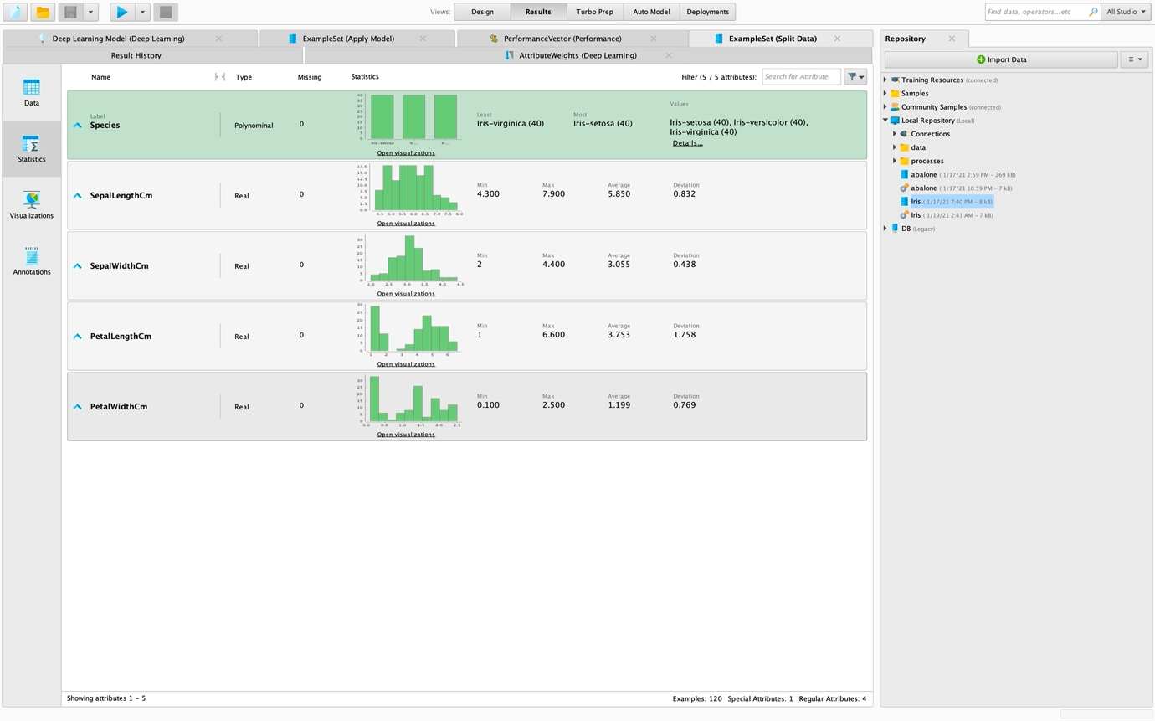To get some graphics and statistical data we need to click Visualizations section or Statistics section shown on the left in picture 3.

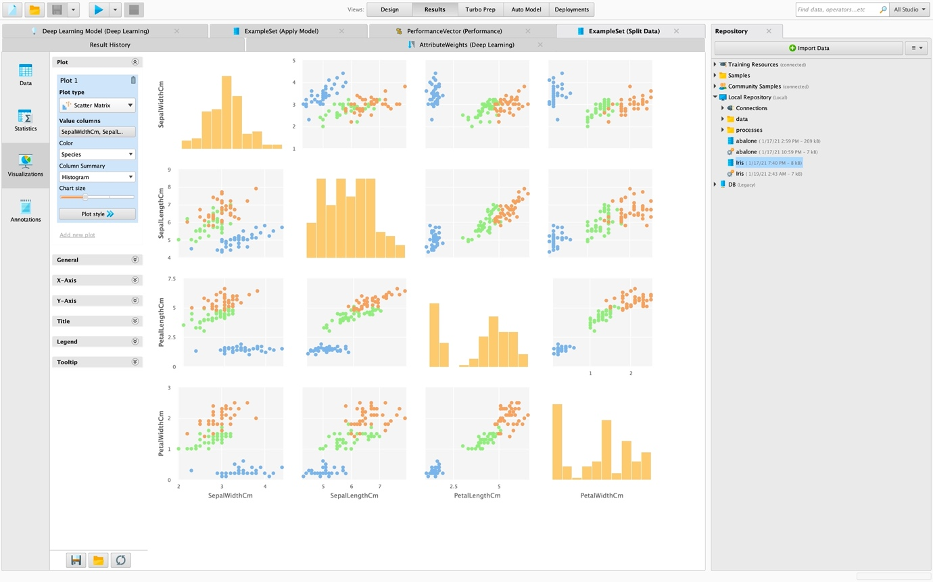

1. CODES

I strongly suggest that check out the code on

<https://github.com/tolgaberk/iris_data_mining>

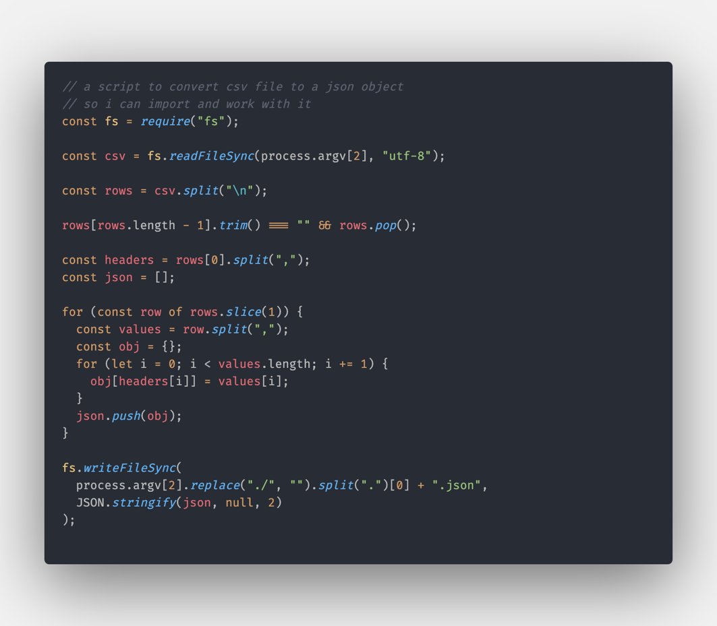

And output is like:

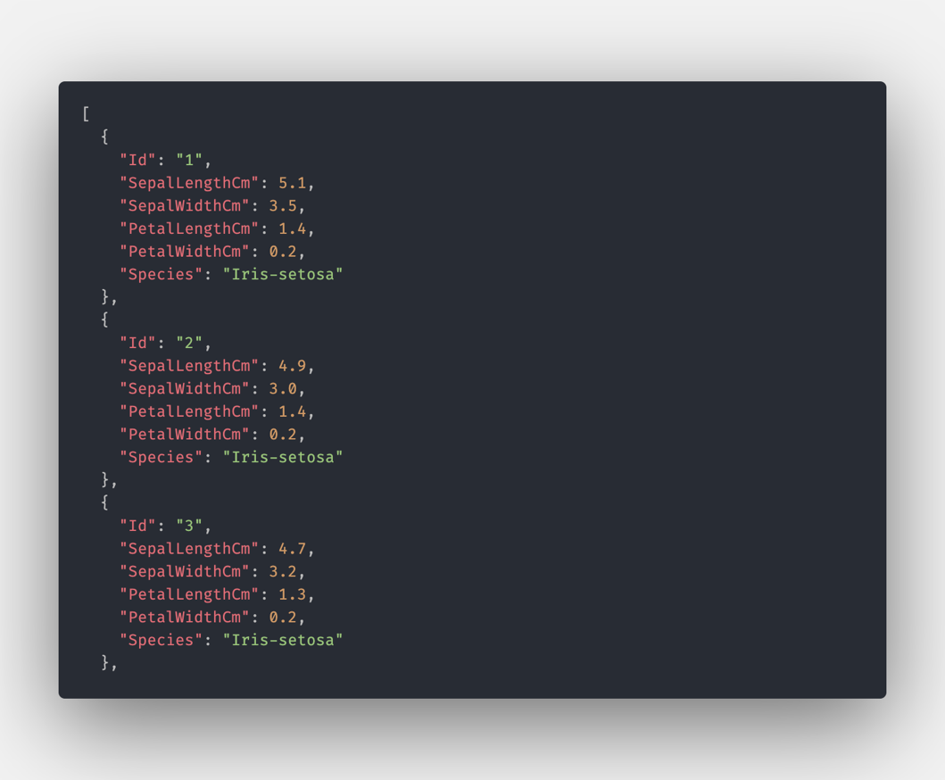

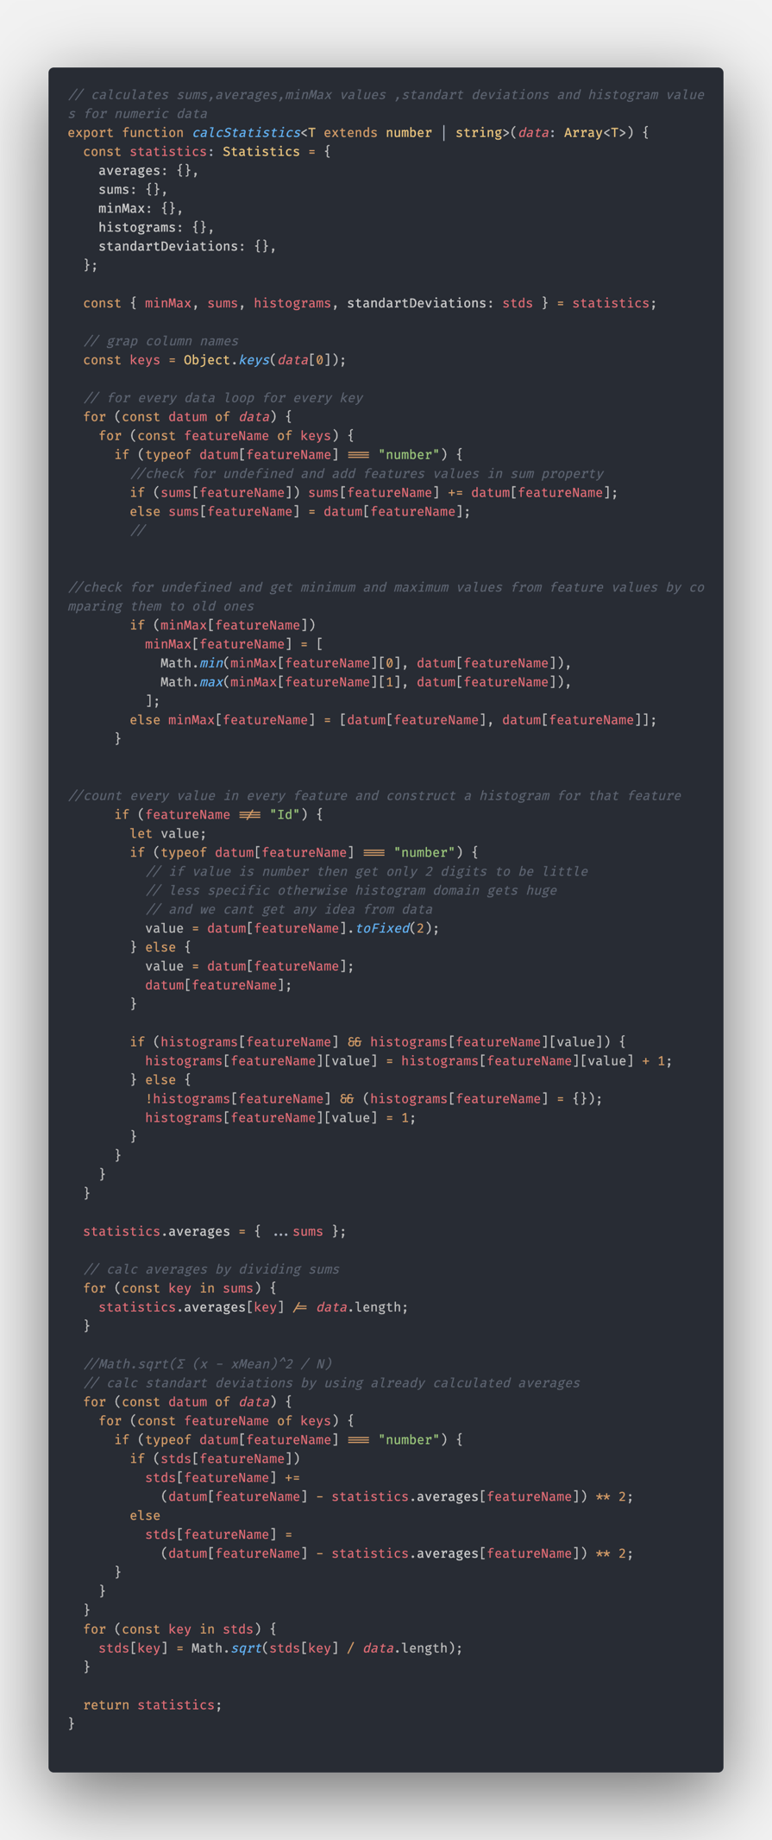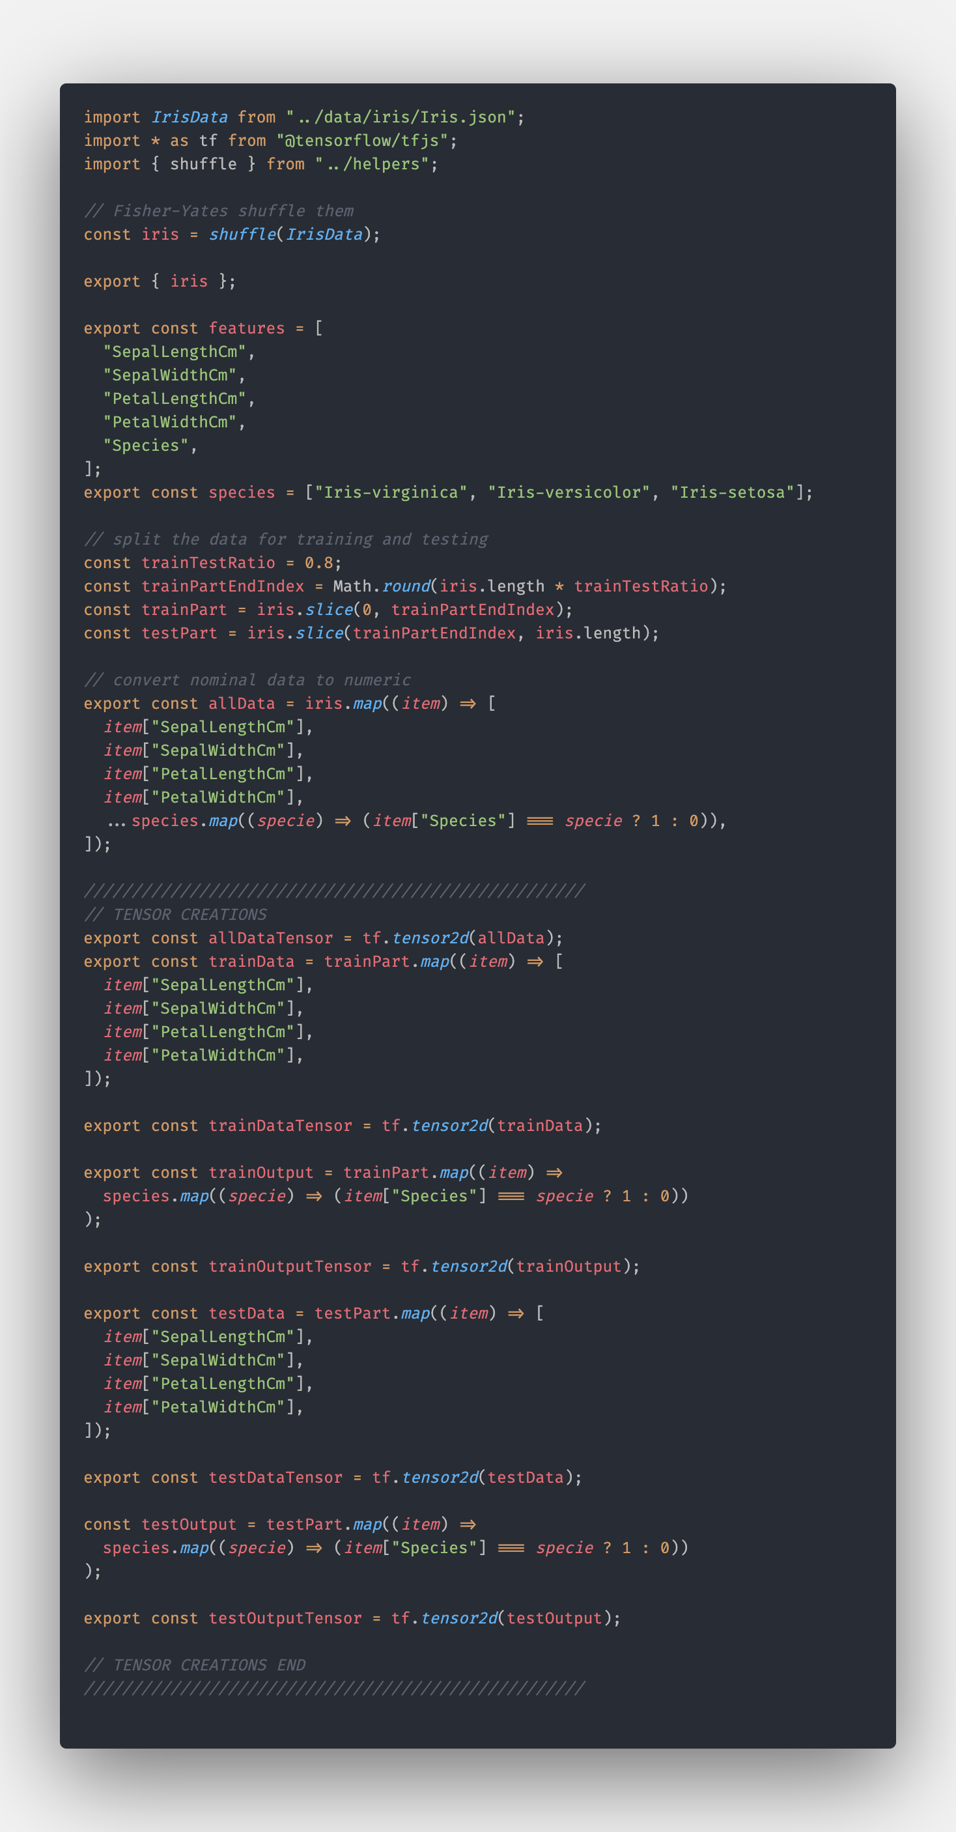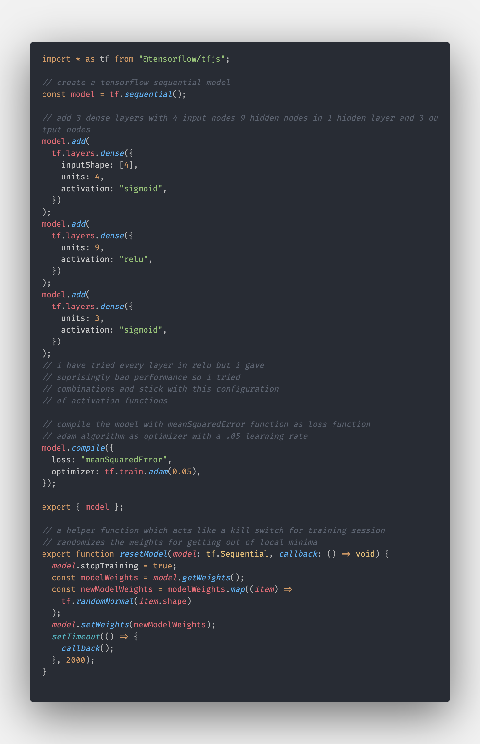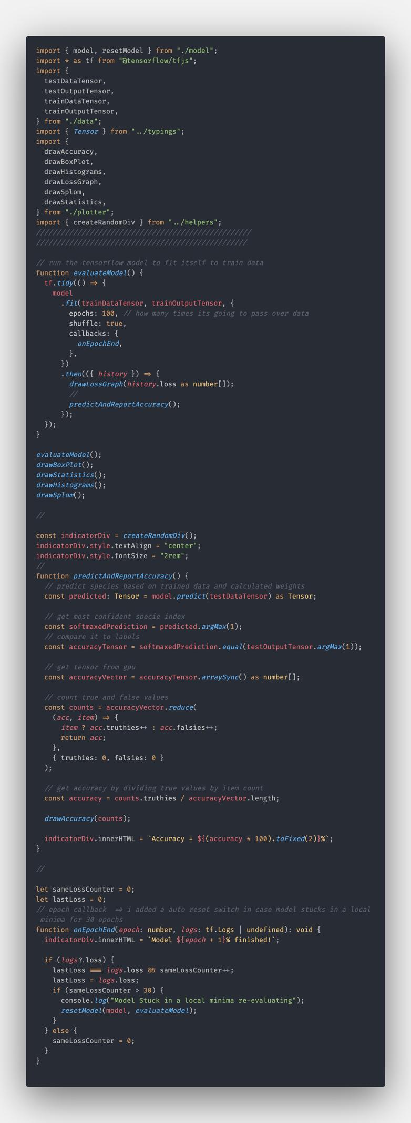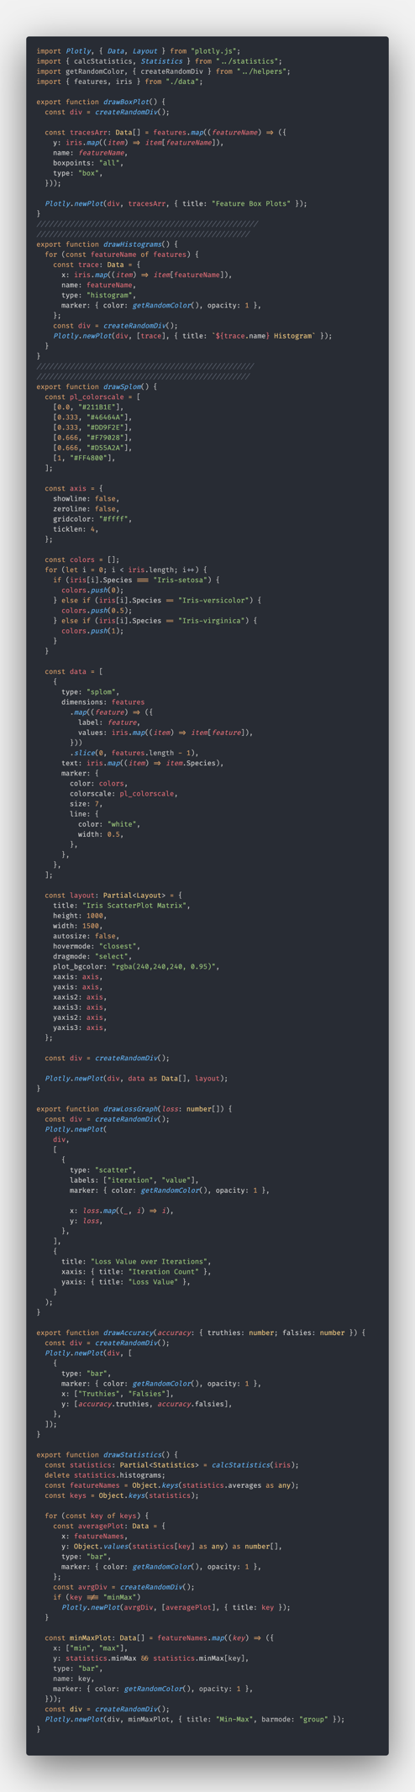

1. RESULTS

Results in RapidMiner :

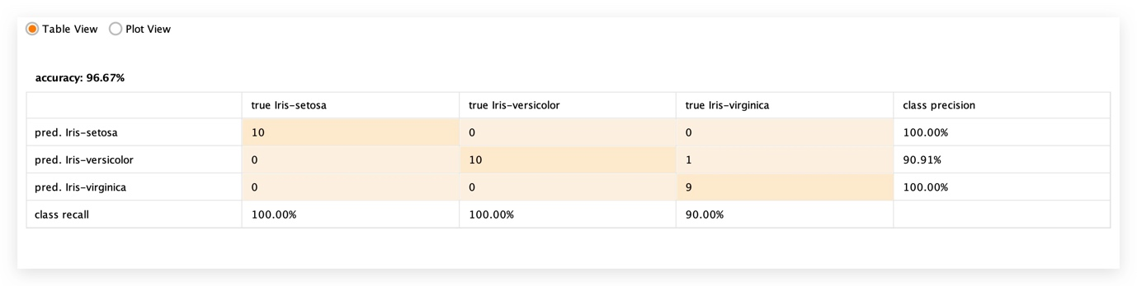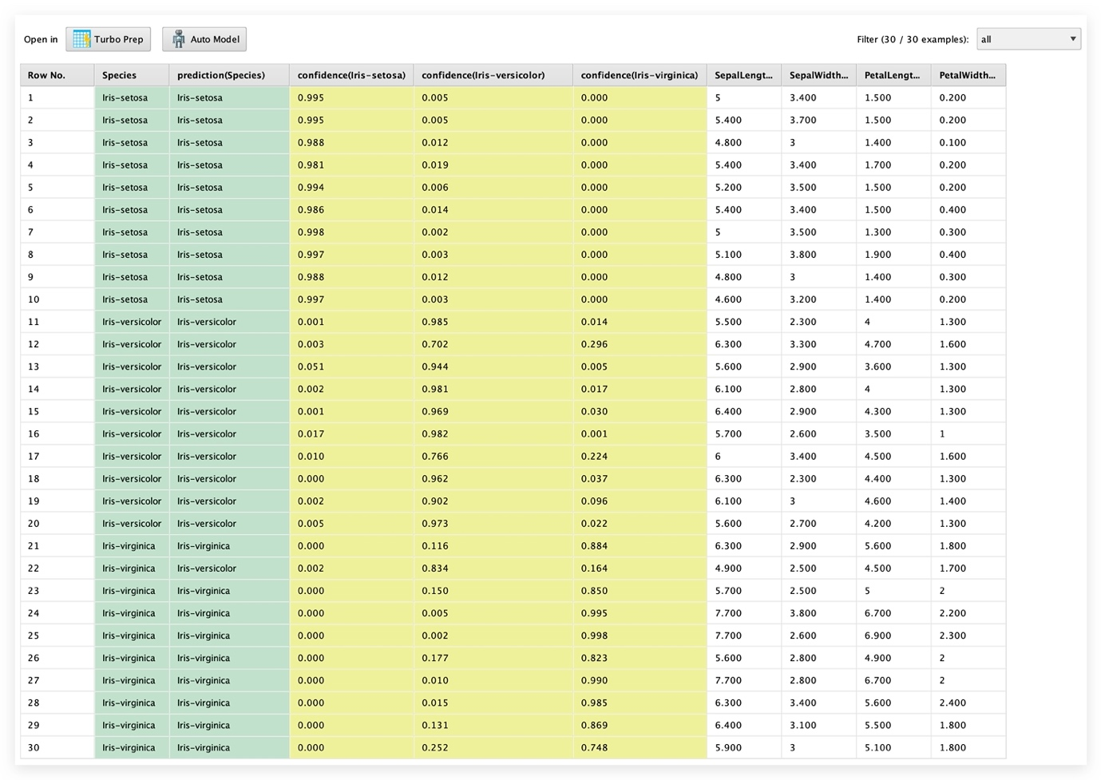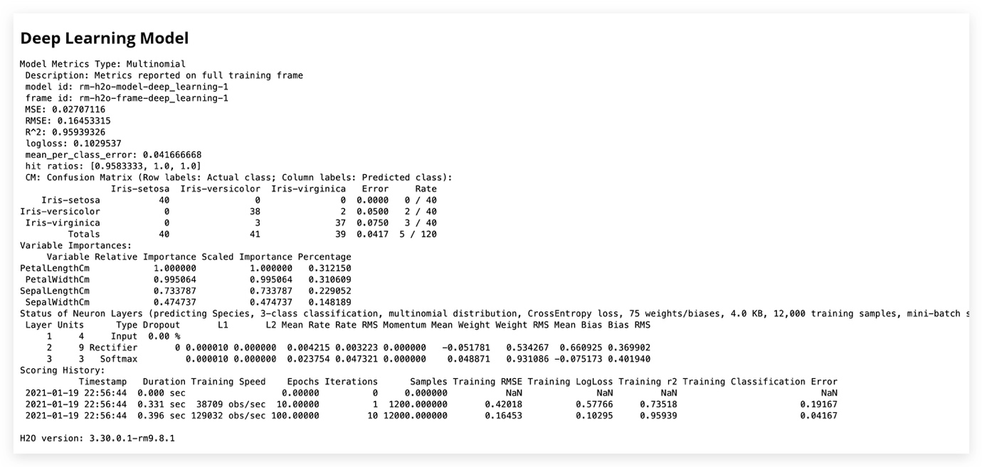

Results in my model :

1. DISCUSSION AND CONCLUSIONS

I GOT NOTHIN MAAN!!!

REFERENCES

U don’t trust me?

CHECKLIST

|  |  |
| --- | --- |
|  | YES / NO |
| Did you prepare your study both using a tool and writing code? | yes |
| Did you prepare your report as mentioned in the template? | yesish |
| Did you add the results (print screen) of your study to the report? | yes |
| Did you rename your report file as asked in the template? | yes |
| Are you uploading the report to the system? | no |
| Are you uploading the codes to the system? | no |